**ME 3291 Homework Assignment**

1. The governing equation for the temperature distribution with time on a 2D square plate measuring 1 unit by1 unit is

∂T/∂t = ∂2T/∂x2 + ∂2T/∂y2 ,

subjected to the Dirichlet boundary conditions for T provided in Fig.1. You are to obtain the following:

(a) The temperature contour plot on the square plate with time, say at t=0.01, 0.1 and at steady state. (You can provide contours at other times too to depict the convergence of the results at steady state.) Take the initial condition at t=0 as T=0.0 for the whole domain.

**50%**

**50%**

(b) Separately, program and compute for the Laplace Equation

∂2T/∂x2 + ∂2T/∂y2 = 0

and obtain the solution for comparison to the steady state solution in (a).

For the above, you have to show clearly how you treat the Dirichlet boundary conditions, provide a listing of your program, and other pertinent workings. The various contour plots can be carried out using the Techp1ot or any other suitable software. (On matrix inversion, you have the choice to use the direct method like Gauss Elimination or indirect iterative methods.)

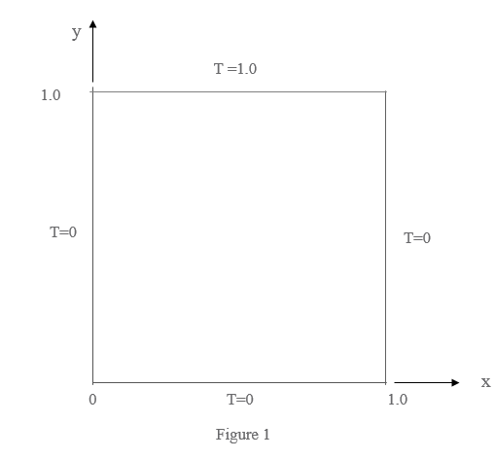

(2) The same governing equation for the temperature distribution with time on a 2D

**50%**

square plate measuring 1 unit by 1 unit is given as

∂T/∂t = ∂2T/∂x2 + ∂2T/∂y2 ,

In this case, the boundary conditions are given as the Dirichlet type for 3 sides of the plate and reflected as follows (Fig. 2),

0 ≤ x ≤ 1.0, y = 0, T = 0.0

0 ≤ x ≤ 1.0, y = 1.0, T = 1.0

0 ≤ y ≤ 1.0, x = 0, T = 0.0

and the Neumann boundary condition for

0 ≤ y ≤ 1.0, x = 1.0,

is given as

∂T/∂x = 0.0.

Obtain the temperature contour plot on the square plate with time, say at=0.01, 0.1 and at steady state. (You can provide contours at other times too to depict the convergence of the results at steady state.)

